**VISVESVARAYA TECHNOLOGICAL UNIVERSITY**

**Jnana Sangama, Belgaum-590018**



**A Web Application Mini Project Report**

**on**

**“TEACH FOR CHANGE”**

**Submitted in Partial fulfillment of the Requirements for the VII Semester of the Degree of**

**Bachelor of Engineering**

**In**

**Computer Science & Engineering**

**By**

**HARITA A**

**(1CR16CS055)**

**KAJOL R SINGH**

**(1CR16CS065)**

**Under the Guidance of**

**Mrs. Savitha S**

**Asst Professor, Dept. of CSE**



# DEPARTMENT OF Computer SCIENCE AND ENGINEERING

**CMR INSTITUTE OF TECHNOLOGY**

#132, AECS LAYOUT, IT PARK ROAD, KUNDALAHALLI,

BANGALORE-560037

**CMR INSTITUTE OF TECHNOLOGY**

1. #132, AECS LAYOUT, IT PARK ROAD, KUNDALAHALLI,
2. BANGALORE-560037

# DEPARTMENT OF Computer SCIENCE AND ENGINEERING

1. 

**CERTIFICATE**

This is to certify that the Web Application Project work entitled **“Teach for change”** has been carried out by **Harita A (1CR16CS055)** and **Kajol R Singh (1CR16CS065)** bonafide students of CMR Institute of Technology in partial fulfillment for the award of **Bachelor of Engineering** in **Computer Science and Engineering** of the Visvesvaraya Technological University, Belgaum during the year **2018-2019**. It is certified that all corrections/suggestions indicated for Internal Assessment have been incorporated in the Report deposited in the departmental library. This Web Project Report has been approved as it satisfies the academic requirements in respect of project work prescribed for the said degree.

**----------------------- ----------------------**

**Signature of Guide Signature of HOD**

**Mrs. Savitha S Dr. Prem Kumar Ramesh**

**Assistant Professor Professor, Head**

**Dept. of CSE, CMRIT Dept. of CSE, CMRIT**

External Viva

Name of the examiners                                                                          Signature with date

1.

2.

# ABSTRACT

This project was the result of the thought that, we, people in the cities are provided with

so many opportunities and resources that in certain cases are more than required for us. A

good use for all this knowledge and opportunities would be to share it with

Under-privileged children in the rural parts.

A common problem in cities is that, though people have the resources, they do not have the means to share it. Thus, the project was developed to help serve this purpose

The website helps people connect with children in government schools of Karnataka.

People could help the students financially by donating, or they could participate in the

activities taking place by volunteering for the events. Updates regarding recent activities

are made in the news section of the website.

# ACKNOWLEDGEMENT

I would like to express my deepest gratitude to Dr.Sanjay Jain, principal, CMR Institute

of Technology, Bangalore for providing an excellent academic environment in the college

and his never-ending support for the B.E program.

I would also like to thank Dr.Jhansi Rani P, Head of the Department, Department of

Computer Science and Engineering, CMR Institute of Technology, Bangalore for

providing us with opportunities and supporting our efforts

I consider it a privilege and honour to express my sincere gratitude to my internal guide

Mrs.Savitha S, Asst. Professor, Department of Computer Science & Engineering, CMR

Institute of Technology, Bangalore for helping and providing valuable guidance

throughout the tenure of this project work.

I would also like to thank all the faculty members who have always been very Co-

operative and generous. Conclusively, I also thank all the non-teaching staff and all others

who have done immense help directly or indirectly during my project.

**HARITA A (1CR16CS055)**

**KAJOL R SINGH (1CR16CS065)**

**TABLE OF CONTENT**

|  |  |  |  |
| --- | --- | --- | --- |
| **Chapter no.** | **Chapter Contents** | | **Page no.** |
| 1. | INTRODUCTION | | 1 |
| 2. | REQUIREMENT ANALYSIS | | 2 |
| 2.1 | Functional requirements | 2 |
| 2.2 | Non-Functional requirements | 2 |
| 3. | SYSTEM REQUIREMENTS | | 3 |
|  | 3.1 | Hardware requirements | 3 |
|  | 3.2 | Software requirements | 3 |
| 4. | DESIGN AND ANALYSIS | | 5 |
| 5. | IMPLEMENTATION | | 6 |
|  | 5.1 | HTML code for front end | 6 |
|  | 5.2 | CSS code for styling | 7 |
|  | 5.3 | JavaScript code | 10 |
|  | 5.4 | Database connection | 11 |
|  | 5.5 | Code for updating an event | 11 |
|  | 5.6 | Code for volunteering for an event | 13 |
|  | 5.7 | Code for news page | 14 |
| 6. | DATABASE DESIGN | | 16 |
| 7. | TESTING | | 17 |
| 8. | SCREENSHOTS | | 18 |
| 9. | CONCLUSION AND FUTURE SCOPE | | 25 |
|  | BIBLIOGRAPHY | | 26 |

|  |  |  |
| --- | --- | --- |
|  |  |  |
|  |  |  |
|  |  |  |

|  |  |  |  |
| --- | --- | --- | --- |
|  |  |  | |
|  | **LIST OF FIGURES AND TABLES**  **FIGURE NO TITLE PAGE NO**  Fig 4.1 Teach for Change Application Design 5  Fig 8.1 Home page 18  Fig 8.2 Admin page 19  Fig 8.3 Update page 19  Fig 8.4 Login page 20  Fig 8.5 Signup page 20  Fig 8.6 About Us 21  Fig 8.7 Contact Us 21  Fig 8.8 Support Us 22  Fig 8.9 Pop up donate form 22  Fig 8.10 News 23  Fig 8.11 Events 23  Fig 8.12 Event registeration form 24 | |  |
|  |  |  | |
|  |  |  | |

**CHAPTER 1**

**INTRODUCTION**

This project is the result of a thought that, we, people in the cities are provided with

so many opportunities and resources that in certain cases are more than required for us. A

good use for all this knowledge and opportunities would be to share it with Under-privileged

children in the rural parts.

There are approximately 50,000 government schools in Karnataka. And, approximately 50 lakh students studying in these schools. These schools are spread across the state, some in cities and some in the rural parts of the state. These students belonging to rural Karnataka are not exposed to the same opportunities academically and financially as students studying in schools in cities.

The idea is to collaborate with these government schools, to help connect the students studying there with people in cities. Help can be provided financially to these students or by interaction.

This application aims in helping those users willing to provide for these students but do not have a way to do the same. Users can now become a member in the site by signing up. They can take part in events conducted by registering for the same. They can be updated with recent activities by reading the news contents. Financial support can also be provided by donating. Monthly events conducted can thus help maintain interaction with the students.

This web application gives a user friendly environment and establishes secure connections.

**Chapter 2**

**REQUIREMENT ANALYSIS**

**2.1 Functional Requirements**

* To organize events in to promote volunteerism.
* To give detailed information about various events organized through this site.
* To enable users to register for the same.
* Giving information about the current events and activities that have taken place.
* Information about various other happenings regarding government schools in Karnataka are also provided.
* Users can also donate through the site to support financially.

**2.2 Non-Functional Requirements**

* To give a user-friendly experience.
* To enable secure transactions.
* To make the application extremely scalable.
* To test the application and ensure maintainability on a timely basis.

**Chapter 3**

**SYSTEM REQUIREMENTS**

**3.1 Hardware Requirements**

* Processors: Intel i3,i5,i7
* Processor Speed: 3.00GHZ
* RAM: 4GB
* Storage: 50GB
* Monitor: 15inches
* Keyboard: Standard 102 keys
* Mouse: Standard 3 buttons

**3.2 Software Requirements**

* Operating System can be either Windows 7,8,9,10, XP.
* Back End/Database: MYSQL
* Tool: XAMPP Server required to simulate DBMS environment
* Notepad++ or Sublime for HTML, CSS, JavaScript and PHP coding.

**3.2.1 Introduction to HTML**

Hypertext Markup Language is the standard markup language for creating web pages and web applications. Web browsers receive Html documents from a web server and render the documents into multimedia web pages. HTML describes the structure of a web page semantically and originally includes cues for the appearance of the document.

**3.2.2 Introduction to CSS**

Cascading style sheets is a style sheet language used for describing the presentation of a document written in a markup language like HTML. CSS is a cornerstone of the world wide web. CSS is designed to enable the separation of presentation and content, including layout, colors, and fonts.

**3.2.3 Introduction to PHP**

Hypertext Preprocessor is a server-side scripting language designed for web development and also used as a general-purpose programming language.

**3.2.4 Introduction to JavaScript**

JavaScript often abbreviated as JS, is a [high-level](https://en.wikipedia.org/wiki/High-level_programming_language), [interpreted](https://en.wikipedia.org/wiki/Interpreted_language) [scripting language](https://en.wikipedia.org/wiki/Scripting_language). As a multi-paradigm language, JS supports event-driven, functional, and [imperative](https://en.wikipedia.org/wiki/Imperative_programming) (including [object-oriented](https://en.wikipedia.org/wiki/Object-oriented_programming) and [prototype-based](https://en.wikipedia.org/wiki/Prototype-based_programming)) [programming styles](https://en.wikipedia.org/wiki/Programming_paradigm). It has [APIs](https://en.wikipedia.org/wiki/Application_programming_interface) for working with text, [arrays](https://en.wikipedia.org/wiki/Array_data_type), dates, [regular expressions](https://en.wikipedia.org/wiki/Regular_expression), and the [DOM](https://en.wikipedia.org/wiki/Document_Object_Model), but the language itself does not include any [I/O](https://en.wikipedia.org/wiki/Input/output), such as [networking](https://en.wikipedia.org/wiki/Computer_network), [storage](https://en.wikipedia.org/wiki/Data_storage), or [graphics](https://en.wikipedia.org/wiki/Computer_graphics) facilities.

**3.2.5 Introduction to SQL**

Structured Query Language is a domain-specific language used in programming and deigned for managing data held in a relational database management system (RDBMS). It is particularly useful in handling structured data where there are relations between different entities/variables of the data.

**CHAPTER 4**

**DESIGN & ANALYSIS**

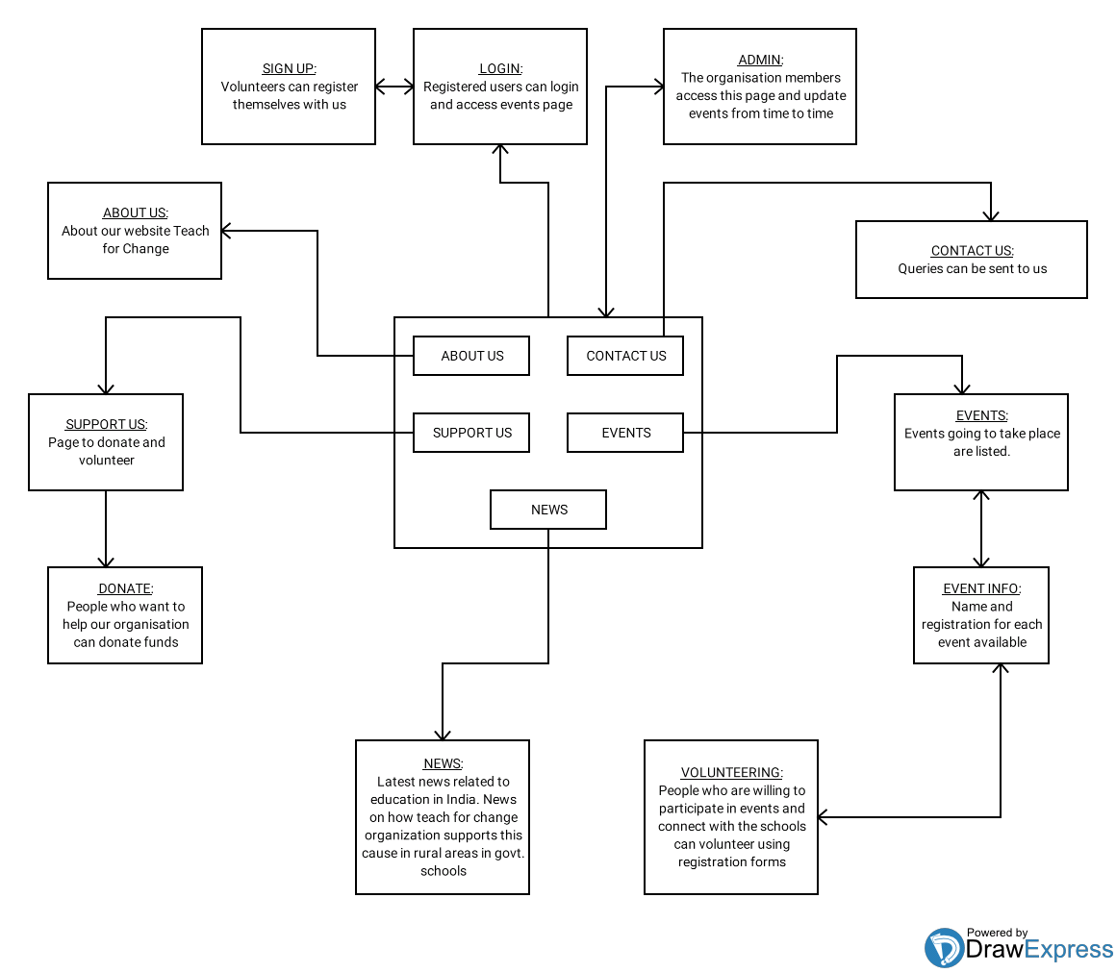

Fig 4.1: Teach for Change Application Design

**CHAPTER 5**

**IMPLEMENTATION**

**5.1 Piece of HTML code for front end**

<!DOCTYPE html>

<html lang="en">

<head>

<meta charset="UTF-8">

<meta name="viewport" content="width=device-witdth, initial-scale=1.0">

<title>teachforchange</title>

<link rel="stylesheet" href="home.css">

<script type="text/javascript" href="home.js"></script>

</head>

<body>

<header>

<div class="wrapper" id="nav">

<center>

<ul class="nav-area">

<li><a href="home.html">HOME</a></li>

<li><a href="about.html">ABOUT</a></li>

<li><a href="sup.html">SUPPORT US</a></li>

<li><a href="login.html">NEWS</a></li>

<li><a href="ev.php">EVENTS</a></li>

<li><a href="login.html">LOGIN</a></li>

<li><a href="contact.html">CONTACT</a></li>

</ul>

</center>

</div>

<div>

<img id="i1" src="logo.jpg" width="200" height="103" padding="none">

<input type="button" value="DONATE" id="b1">

<input type="button" value="VOLUNTEER" id="b2">

<center>

<p id="q">

<h1 class="font_3" style="line-height:1.2em; padding-top:100px;text-align:center;"><span style="font-family:cursive; "><span style="font-weight:bold;"><span class="color_11">Believe in the power&nbsp;</span></span></span></h1>

<h1 class="font_3" style="line-height:1.2em; text-align:center;"><span style="font-family:cursive; "><span style="font-weight:bold;"><span class="color_11">Of Education</span></span></span></h1>

</p>

</center>

</div>

</body>

</html>

**5.2 CSS code for styling web page**

*{

margin: 0;

padding: 0;

}

.wrapper{

align-content: center;

width:1450px;

position: fixed;

}

header{

background-color: grey;

height: 100vh;

-webkit-background-size:cover;

background-size: cover;

background-position: center center;

position: relative;

background-image: url("pic3.jpg");

background-attachment: fixed;

overflow-wrap: break-word;

}

.nav-area{

background-color: rgba(0,0,0,0.6);

background-position: 100%;

align-content: center;

list-style:none;

padding: 40px 40px 40px 40px;

display: block;

top: 0;

overflow:hidden;

}

.nav-area li{

display: inline-block;

}

.nav-area li a{

color: white;

text-decoration: none;

padding: 10px 20px;

font-family: poppins;

font-size: 20px;

}

.nav-area li a:hover{

color: pink;

}

.beforescroll{

height: 100px;

width: 100px;

display: none;

}

.afterscroll{

height:100px;

width:100%;

display: block;

font-family: "Luna";

font-size:14px;

}

.content{

padding:10px;

}

.sticky{

position:fixed;

top:0;

width: 100%;

}

.sticky + .content

{

padding-top: 102px;

}

**5.3 Piece of JavaScript code**

window.onscroll=function()

{myfunction()};

var header=document.getElementById('myheader');

var im=document.getElementById('im');

function myfunction()

{

if(window.pageYOffset>sticky){

header.classList.add("sticky");

im.classList.add("sticky");

}

else

{

header.classList.remove("sticky");

im.classList.remove("sticky");

}

}

var nav=document.getElementById('nav');

window.onscroll=function(){

if(window.pageYOffset>100)

{

nav.style.position="fixed";

nav.style.top= 0;

}

}

**5.4 Code for Database Connection**

<?php

$host="localhost";

$user="root";

$password="";

$db="ngo";

$conn=mysqli_connect($host,$user,$password)or DIE('Connection to host is failed,perhaps the service is down!');

mysqli_select_db($conn,$db) or DIE('Database name is not available!');

?>

**5.5 Code for updating an event**

<?php

session_start();

if(isset($_SESSION['username'])){

echo '<!DOCTYPE html>

<html>

<h1>Update events :</h1>

<div id="content" >

<form method="post" action="up.php" enctype="multipart/form-data" id="signupform">

<input type="hidden" name="size" value="1000000">

<div>

<input type="text" name="eventname" id="button" placeholder="event name"/><br>

</div>

<div>

<input type="file" name="image" style="font-size:17px;margin-left:40px;color:yellow;">

</div>

<br>

<div>

<a href="#"><input type="submit" style="font-size:18px;margin-left:38px;background-color:#7cfc00a8;padding:8px 15px;text-shadow:1px 1px 0px;font-family:cursive;" name="upload" value="Upload Pet Details"></a>

</div>

</form>

</body>

</html>';

}

else{

$username=$_POST['username'];

$password=$_POST['password'];

if(!empty($username)|| !empty($password))

{

$host = "localhost";

$dbusername = "root";

$dbpassword = "";

$dbname="ngo";

//create connection

$conn=new mysqli($host,$dbusername,$dbpassword,$dbname);

//check connection

if(mysqli_connect_error())

{

die('Connect Error('.mysqli_connect_errno().')'.mysqli_connect_error());

}else{

$q=mysqli_query($conn,"CALL admin('$username','$password')");

$row=mysqli_fetch_array($q);

if($username==$row['user']&& $password==$row['pass'])

{ $_SESSION['username']=$row["user"];

$_SESSION['password']=$row["pass"];

header("location:update.php");}

else{

echo'<script>alert("Invalid Username and Password!")</script>';

header("refresh:1;url=admin.html");

}}

}else{

echo "all feilds are required";

die(); }?>

**5.6 Code for volunteering for an event**

<?php

$n=$_POST["name"];

$e=$_POST["email"];

$p=$_POST["phno"];

if(!empty($n) && !empty($e) && !empty($p))

{

$host="localhost";

$dbusername="root";

$dbpassword="";

$dbname="ngo";

$conn=new mysqli($host,$dbusername,$dbpassword,$dbname);

if(mysqli_connect_error()){

die("connect error(".mysqli_connect_errno().")".mysql_connect_error());

}

else

{

$sql="INSERT INTO reg_events(name,email_id,phno,ev_id) values ('$n','$e','$p','1')";

if($conn->query($sql)){

//echo "<script>alert('Registeration completed')</script>";

echo“<script type='text/javascript'>alert('Registeration completed')</script>";

echo "<script>window.location='ev.php'</script>";}

else

{ echo "<script type='text/javascript'>alert('Error')</script>";

echo "<script>window.location='ev.php'</script>";

}$conn->close();

}}

else

{ echo "<script>alert('all fields required')</script>";

die();

}?>

**5.7 Code for News page**

<div id="slider">

<div id="box">

<img id="im1" src="n3.jpg">

<!--<div align="center" style="padding-top: 20px;padding-bottom: 20px;">-->

<a href="#newss0"><input align="center" type="button" name="readmore" value="READMORE" style="padding: 20px 60px 20px 60px;color: white; cursor: pointer; font-family: poppins; font-size: 20px; position: relative; margin-left: 400px; margin-top: -500px; text-align: center;background-color:#e6195f;"></a>

<!--</div>-->

</div>

<button class="prew fa fa-chevron-left" onclick="prewImage()"></button>

<button class="next fa fa-chevron-right" onclick="nextImage()"></button>

</div>

<script>

var slider_content = document.getElementById('box');

var image = ['n3','d'];

var ne = [0, 1];

var i = image.length;

var j=ne.length;

function nextImage(){

if (i<image.length) {

i= i+1;

j= j+1;

}else{

i = 1;

j = 0;

}

slider_content.innerHTML ="<img id='im1' src="+image[i-1]+".jpg><a href=#newss"+ne[j]+"><input align='center' type='button' name='readmore' value='READMORE' style='padding: 20px 60px 20px 60px;color: white; cursor: pointer; font-family: poppins; font-size: 20px; position: relative; margin-left: 400px; margin-top: -500px; text-align: center;background-color:#e6195f;'></a>";

}

function prewImage(){

if (i<image.length+1 && i>1) {

i= i-1;

j= j-1;

}else{

i = image.length;

j = ne.length;

}

slider_content.innerHTML ="<img id='im1' src="+image[i-1]+".jpg><a href=#newss"+ne[j]+"><input align='center' type='button' name='readmore' value='READMORE' style='padding: 20px 60px 20px 60px;color: white; cursor: pointer; font-family: poppins; font-size: 20px; position: relative; margin-left: 400px; margin-top: -500px; text-align: center;background-color:#e6195f;'></a>"; }

setInterval(nextImage , 4000); </script>

**CHAPTER 6**

**DATABASE DESIGN**

**6.1 Creating Tables**

* Admin: CREATE TABLE `admin` (`user` varchar(50) NOT NULL, `pass` varchar(50) NOT NULL)
* Events: CREATE TABLE `eve` ( `ev_id` int(200) NOT NULL AUTO_INCREMENT, `eventname` varchar(200) NOT NULL, `image` varchar(200) NOT NULL, `location` varchar(500) NOT NULL, `ti` varchar(50) NOT NULL, `dat` varchar(30) NOT NULL, PRIMARY KEY (`ev_id`))
* VolunteerCREATE TABLE `volunteer` ( `first_name` varchar(50) NOT NULL,  
   `last_name` varchar(50) NOT NULL, `email_id` varchar(50) NOT NULL,  
   `ph_no` varchar(15) NOT NULL, `gender` varchar(10) NOT NULL,  
   `password` varchar(10) NOT NULL, PRIMARY KEY (`email_id`))
* Registering: CREATE TABLE `reg_events` ( `slno` int(200) NOT NULL AUTO_INCREMENT, `name` varchar(50) NOT NULL, `email_id` varchar(200) NOT NULL, `phno` varchar(20) NOT NULL, `ev_id` int(50) NOT NULL, PRIMARY KEY (`slno`),  
   KEY `username` (`name`), KEY `ev_id` (`ev_id`), CONSTRAINT `reg_events_ibfk_2` FOREIGN KEY (`ev_id`) REFERENCES `eve` (`ev_id`))

**6.2 Inserting data into the tables**

INSERT INTO `volunteer` (`first_name`, `last_name`, `email_id`, `ph_no`, `gender`, `password`) VALUES ('Tejaswini ', 'G singh', 'tejaswinigsingh@gmail.com', '9739732169', 'Female', 'teju24');

**CHAPTER 7**

**TESTING**

**7.1 Functionality Testing**

* Database connection is successfully established.
* The flow of the website from one page to another is correct, accurate and quick.
* All the forms included in the website are working as expected.
* Proper alert messages are displayed in case of wrong inputs.
* After every action on the website the same was reflected in the database.
* The application was tested multiple times and same results were obtained.

**7.2 Usability Testing**

* The application enables smooth navigation, hence gives a user friendly experience.
* The content provided by the application is verified and is taken by the trusted sources.

**7.3 Interface Testing**

* The application connects correctly with the server. In case of failure appropriate message is displayed.
* Interruptions by the server or by the user are handled efficiently.

**7.4 Compatibility Testing**

* This web application is compatible with all the browsers enabled with JavaScript.

**7.5 Performance Testing**

* It works fine with moderate internet speed.
* The connection is secured and user details are stored in a secured manner.

**CHAPTER 8**

**SCREENSHOTS**



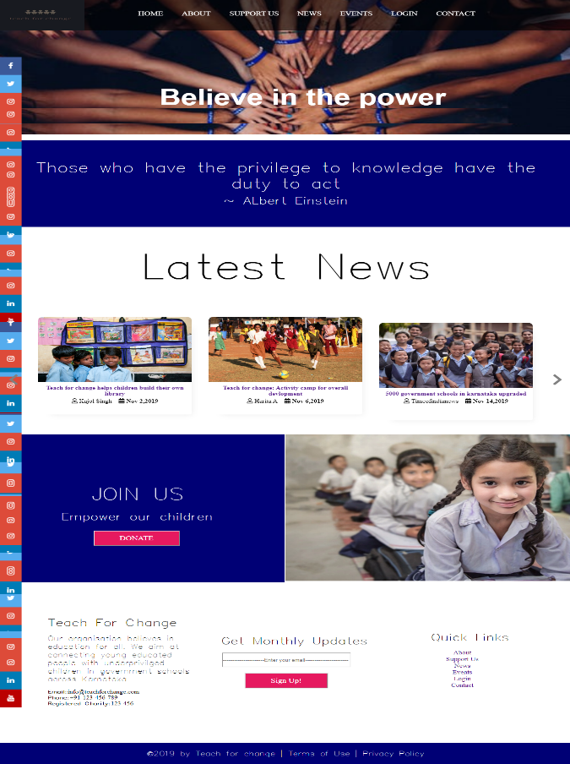

Fig 8.1: Home page

The home page of teach for change website with a slider news carousel and footer.



Fig 8.2: Admin Page

In the Admin page, log in for the admin to update events.

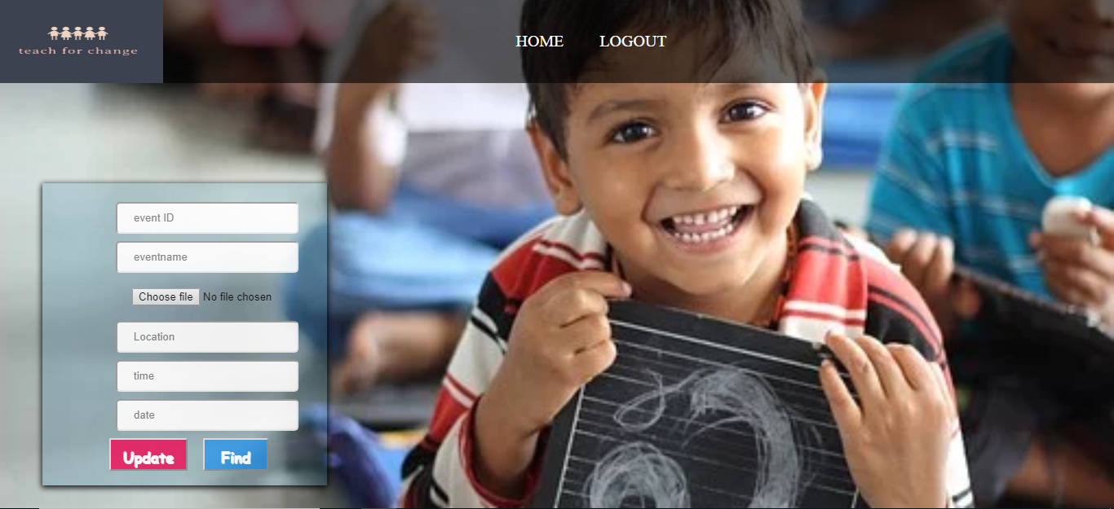

Fig 8.3: Update Page

Admin can update new events by filling this form which will eventually update the events page on the website.

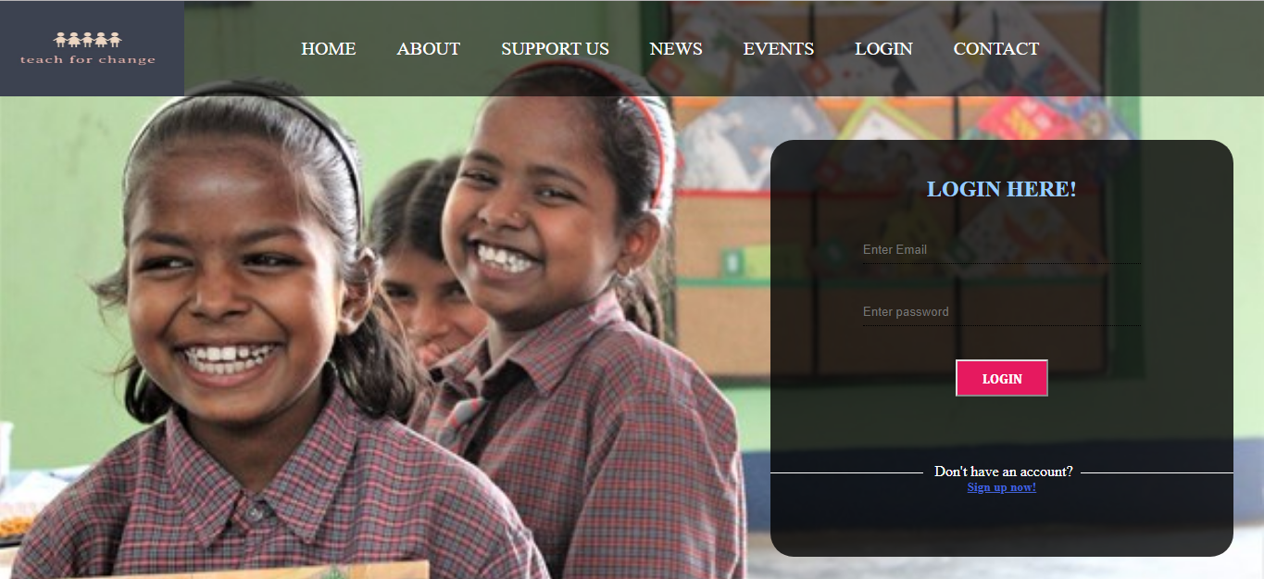

Fig 8.4: Login page

People who want to volunteer for an event will explore the events going to take place in the event page by logging in to their accounts.

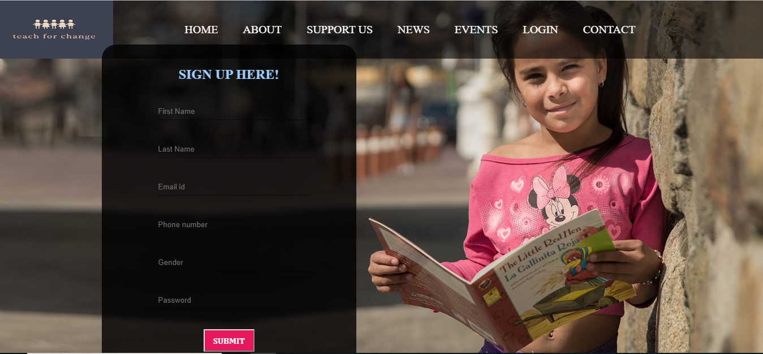

Fig 8.5: Signup page

Users who want to volunteer and become a member by registering themselves.

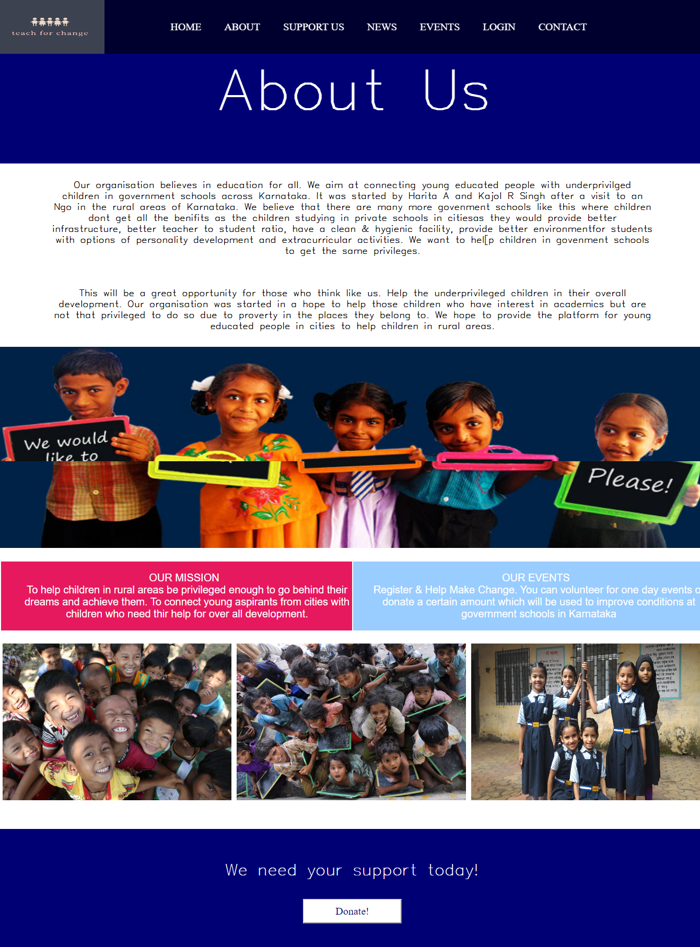

Fig 8.6: About Us

About us page contains theTeach for change website details.

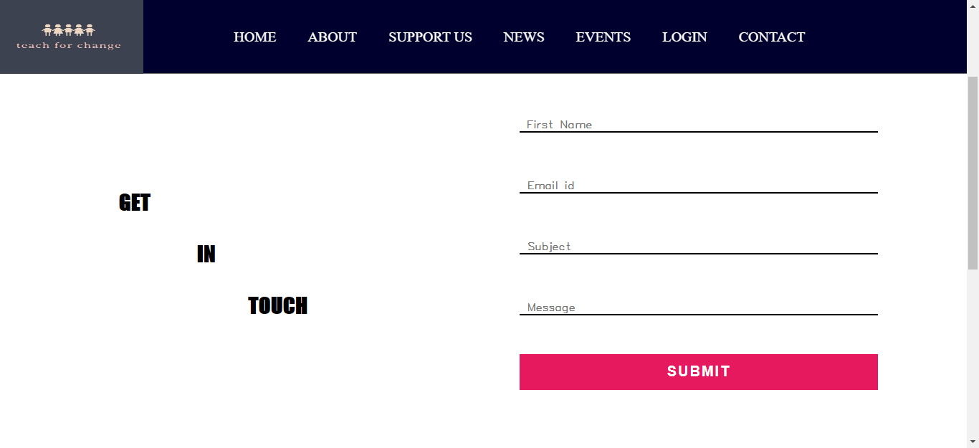

Fig 8.7: Contact Us Page

Organisers,volunteers and the people wanting to contact us for any queries can send message to us through contact us page.

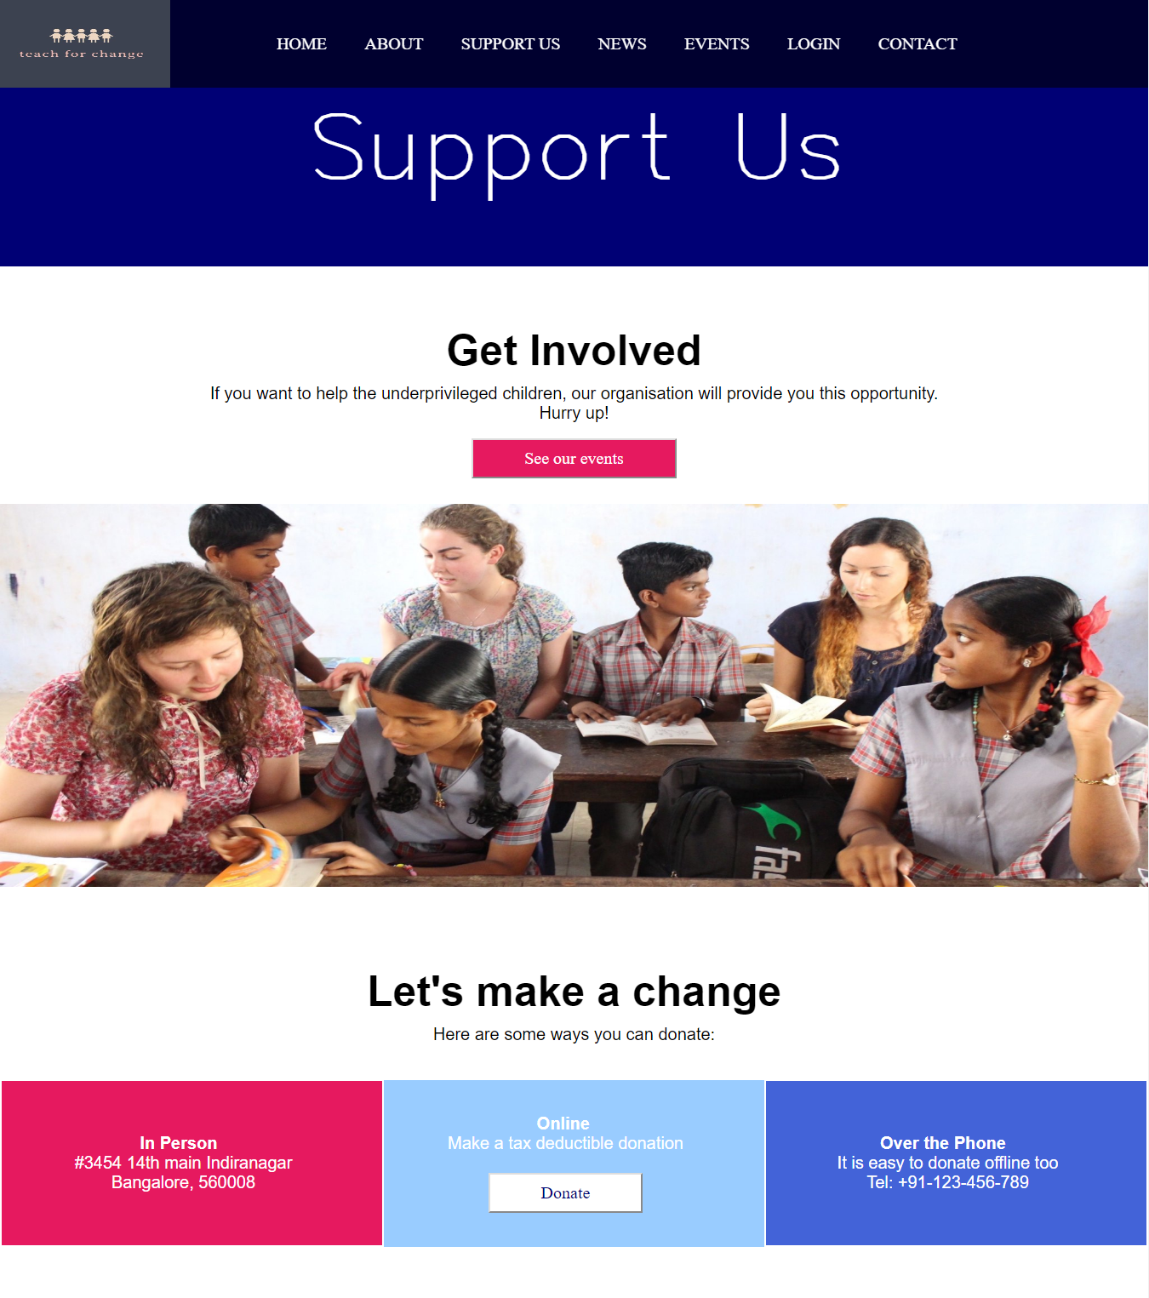

Fig 8.8: Support Us

Support Us page to donate or volunteer.

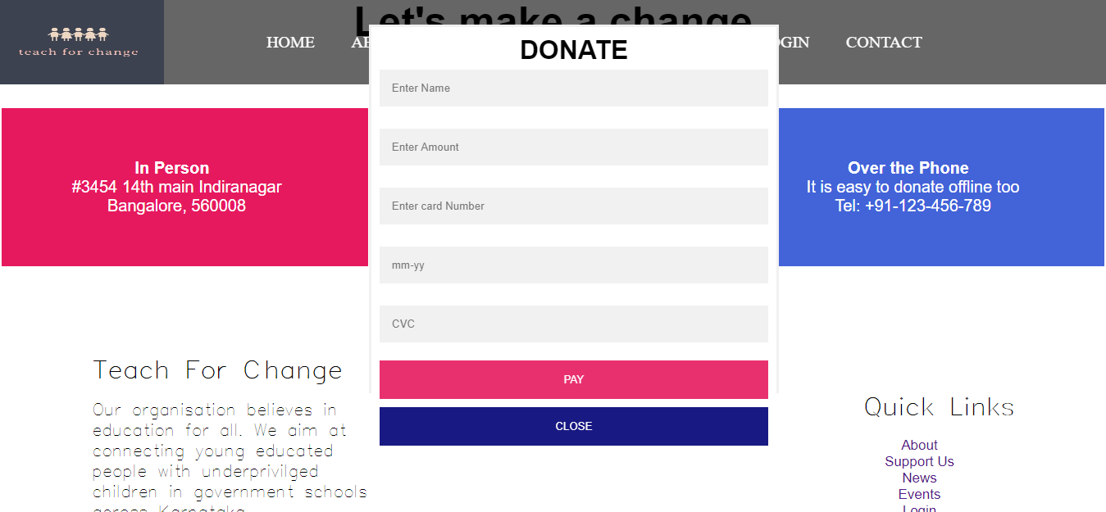

Fig 8.9: Pop Up Donate form

People who want provide financial help by donating certain amount.

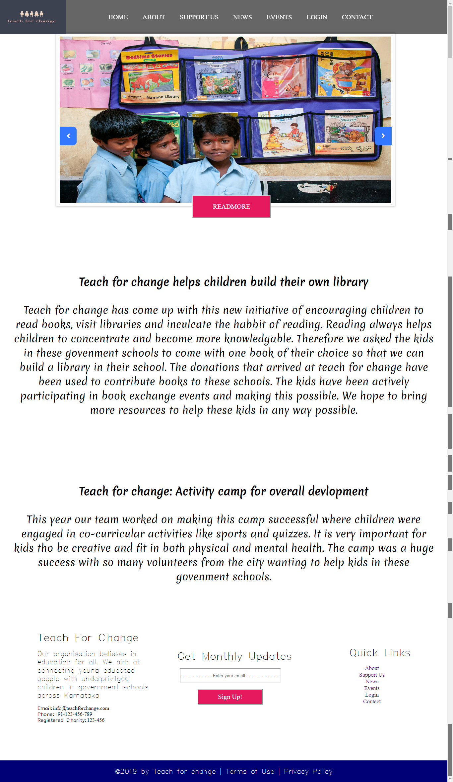

Fig 8.10: News Page

Details on latest news on education as well as teach for change initiatives.

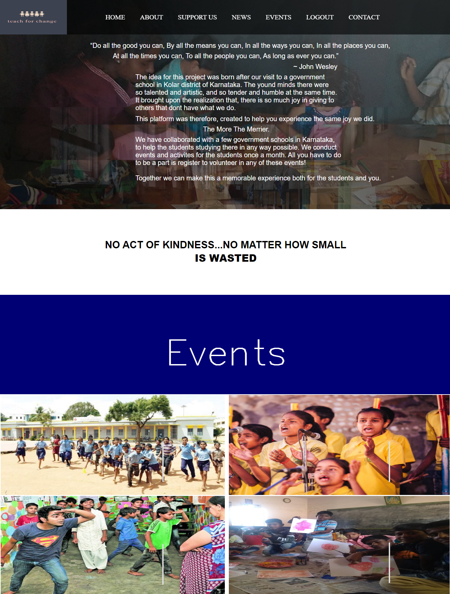

Fig 8.11: Events

Users can look at the events available and register to volunteer.

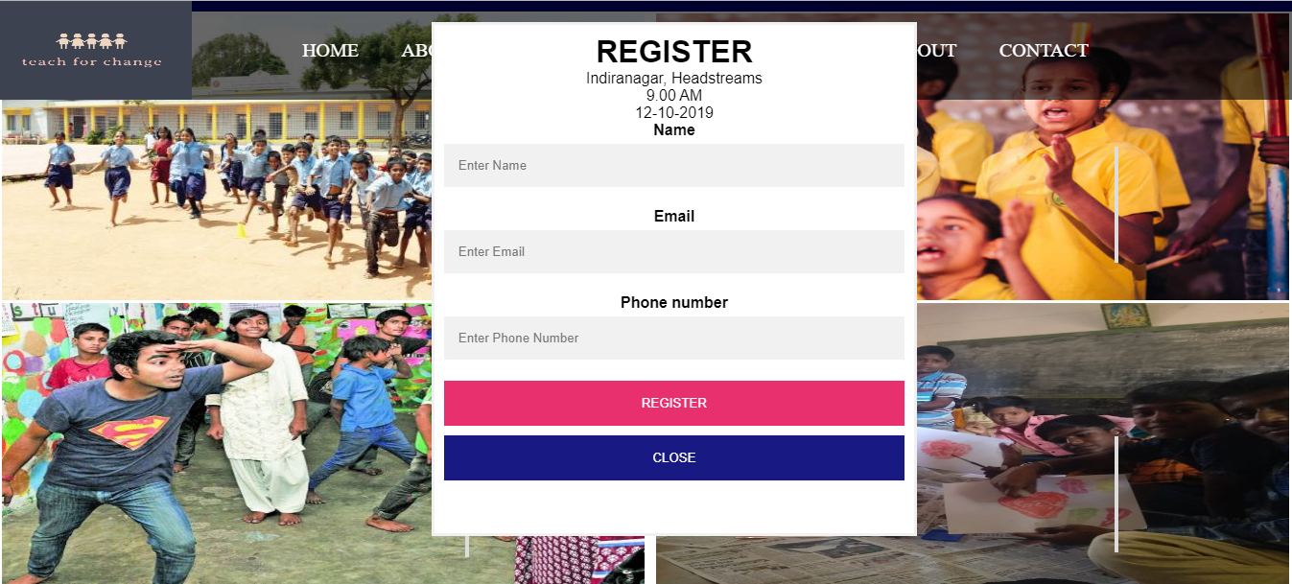

Fig 8.12: Event register form

Users can participate in events by filling this form on the events page of the website.

**CHAPTER 9**

**CONCLUSION AND FUTURE SCOPE**

This is to conclude that the project we undertook has been worked upon with sincere effort and has been completed successfully. The requirements and goals of the project have been achieved. The web application has been thoroughly tested and can now be implemented in the real world. By this project I hope to bring satisfaction to the users and meet their expectations.

**BIBLIOGRAPHY**

1. Fundamentals of Web development by Cannolly Hoar
2. www.w3schools.com
3. www.stackoverflow.com
4. https://smartslider3.com/product-carousel/
5. https://www.youtube.com/watch?v=U13smZvdArI